

**COLLEGE CODE**

**:9111**

**COLLEGE NAME**

**:**

**SRM MCET**

**DEPARTMENT**

**:**

**CSE**

**STUDENTNMROLLNO:**

**F527DD6EC9EEBE39B9E46539353F079E**

**DATE :29/09/2025**

**Completed the project named as**

**Phase__**

**4**

**TECHNOLOGY PROJECT**

**NAME :SINGLE PAGE APPILICATION**

**SUBMITTED BY,**

**NAME:PRIYADHARSHINI. G**

**MOBILENO:7639065221**

# IBM-FE –Single Page Application Phase 4- Enhancements & Deployment

* **Focus:** Developing a modern web application using front-end technologies (like React, Angular, or Vue.js), likely incorporating **IBM's design systems** (e.g., **Carbon Design System**) for consistent UI/UX.
* **Key-Points:** The entire application loads a single HTML page and dynamically updates content using JavaScript, providing a fast, fluid, and **desktop-like user experience**.

# Additional Features

* **Focus:** Implementing new functionalities beyond the application's **Minimum Viable Product (MVP)** or initial scope.
* **Key-Points:** This phase involves requirements gathering, design, and development of new components, business logic, or third-party integrations (e.g., adding user authentication, a complex data visualization dashboard, or a payment gateway).

# UI/UX Improvements

* **Focus:** Enhancing the **User Interface (UI)** aesthetic and the **User Experience (UX)** flow, usability, and accessibility.
* **Key-Points:** Activities include **A/B testing**, conducting user interviews, refining visual design (typography, color palette), improving **responsiveness** across different devices, and ensuring compliance with **accessibility standards (WCAG)**.

# API Enhancements

* **Focus:** Modifying, optimizing, or expanding the **Backend Application Programming Interfaces (APIs)** that the front-end SPA consumes.
* **Key-Points:** This often involves improving **API response times**, adding new endpoints to support front-end features, updating data models, ensuring **data security**, and implementing features like **caching** or **rate limiting**.

# Performance & Security Checks

* **Focus:** Auditing the application's speed, efficiency, stability, and protection against threats.
* **Key-Points - Performance:** Use tools like **Lighthouse** or WebPageTest to measure metrics (e.g., **First Contentful Paint, Time to Interactive**), optimize asset loading (lazy loading, compression), and minimize bundle size.
* **Key-Points - Security:** Conduct **vulnerability scanning**, address common web vulnerabilities (**OWASP Top 10**), ensure secure data transmission (**HTTPS**), and implement proper **CORS** and **authentication/authorization** mechanisms.

# Testing Of Enhancements

* **Focus:** Verifying that all new features, UI/UX changes, and API enhancements function correctly, meet requirements, and haven't introduced regressions.
* **Key-Points:** Includes different testing types: **Unit Tests** (for small code units), **Integration Tests** (for system components working together), **End-to-End (E2E) Tests** (simulating user flows), and **User Acceptance Testing (UAT)**.

# Deployment (netlify, Vercel, or cloud Platform)

* **Focus:** Making the final, tested application available to end-users on a reliable hosting service.
* **Key-Points:** This involves **Continuous Integration/Continuous Deployment (CI/CD)** setup. Platforms like **Netlify** or **Vercel** are popular for static SPAs due to their ease of use, global CDN, and automatic build processes, while a more robust **cloud platform** (like IBM Cloud, AWS, Azure, or GCP) might be used for the backend APIs.

**Program:**

<!DOCTYPE html>

<html lang="en">

<head>

<meta charset="UTF-8">

<meta name="viewport" content="width=device-width, initial-scale=1.0">

<title>Simple SPA</title>

<style> body { font-family: Arial, sans-serif; text-align: center; padding: 20px; }

nav button { margin: 5px; padding: 10px 20px; }

#content { margin-top: 20px; font-size: 18px; } </style>

</head>

<body>

<h1>My Simple SPA</h1>

<nav>

<button onclick="showPage('home')">Home</button>

<button onclick="showPage('about')">About</button>

<button onclick="showPage('contact')">Contact</button>

</nav>

<div id="content">Welcome to the Home page!</div>

<script> function showPage(page) {

const content = document.getElementById('content'); if(page === 'home') {

content.innerHTML = 'Welcome to the Home page!';

} else if(page === 'about') { content.innerHTML = 'This is a simple SPA example created using

HTML, CSS, and JS.';

} else if(page === 'contact') { content.innerHTML = 'Contact us at: example@example.com';

}

}

</script>

</body>

</html>

**OUTPUT:**

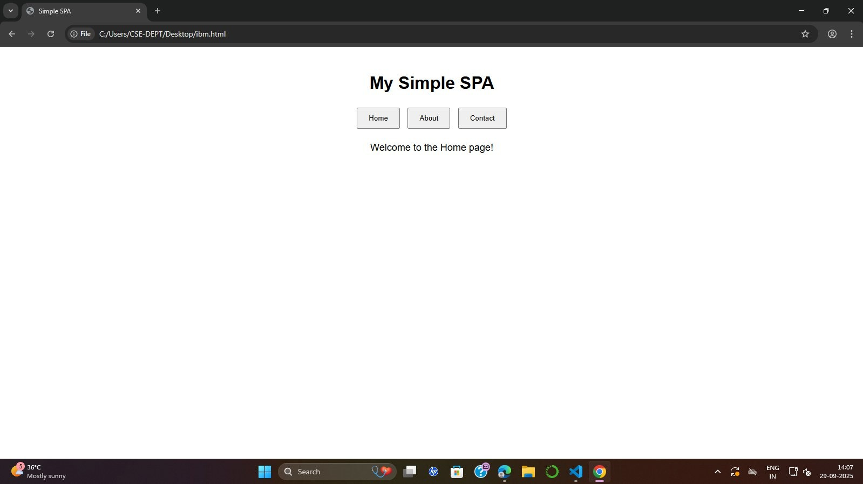

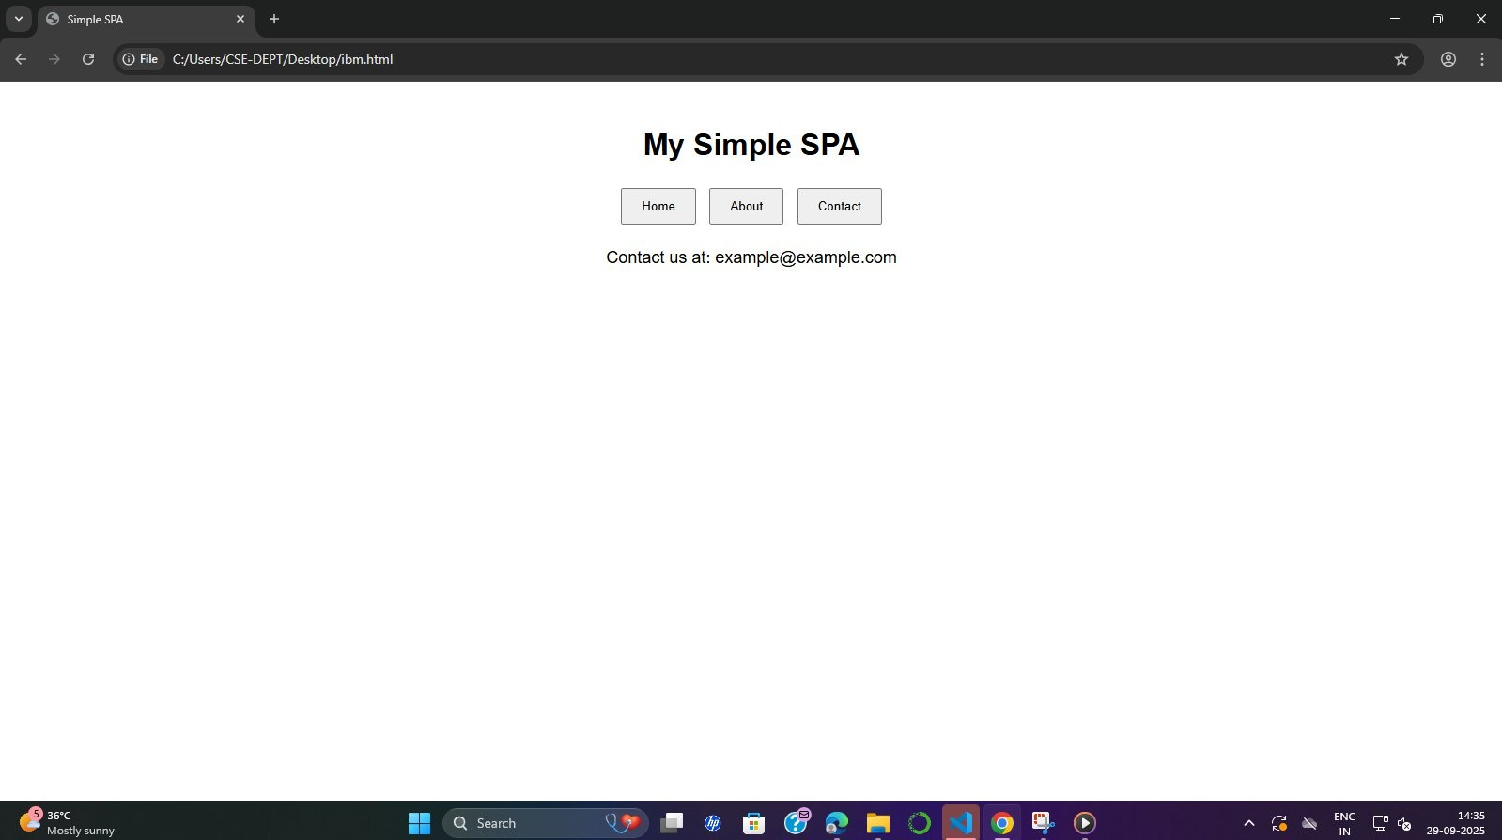

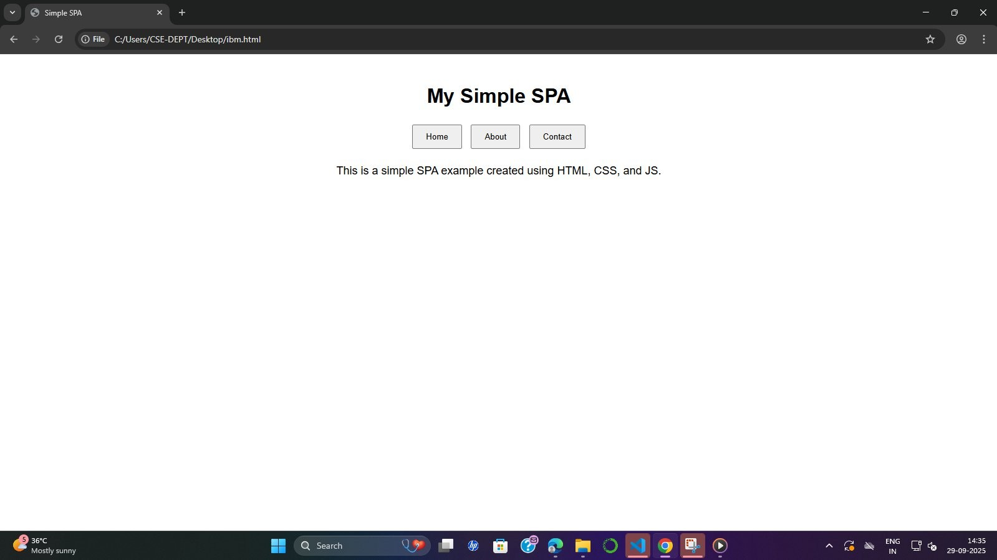

# Deployment Command Sequence (The Execution Program)

This sequence runs during the final **Deployment** phase (e.g., on a service like Netlify / Vercel).

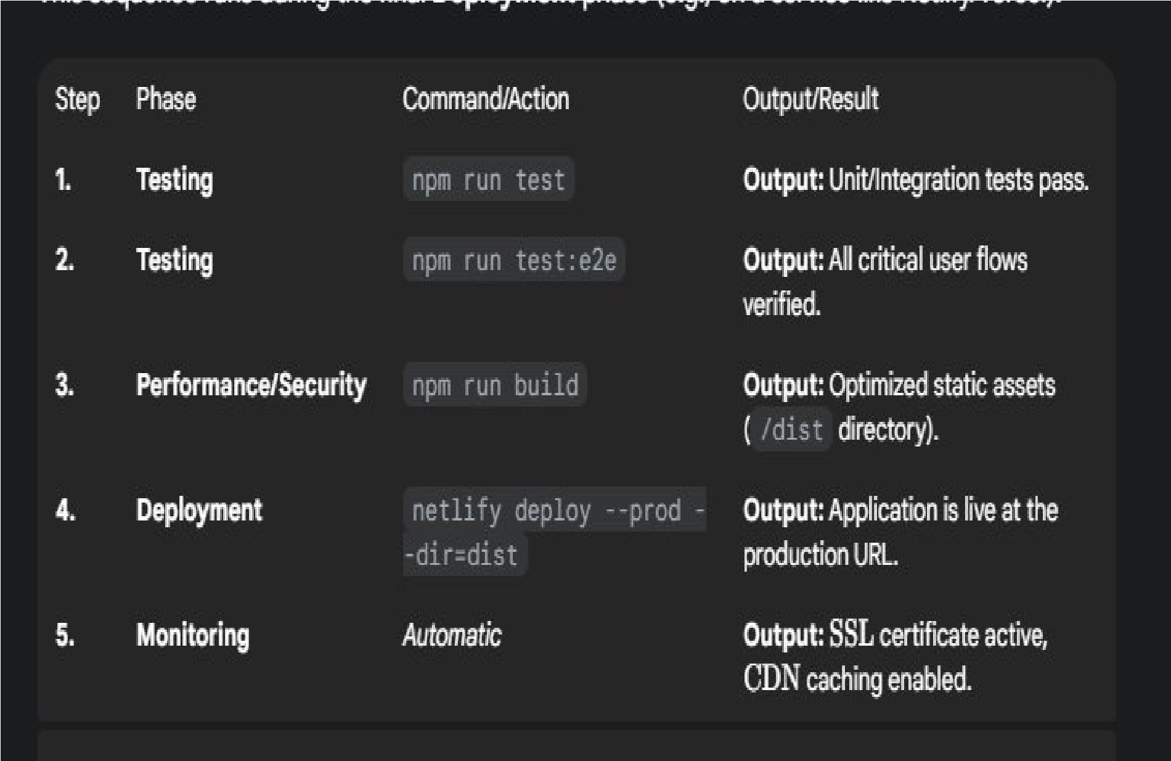

**DRIVE LINK:**

[**https://drive.google.com/file/d/1Er-**](https://drive.google.com/file/d/1Er-6ozdGLcYJQPpneEjHJgnR0cLewMKd/view?usp=drivesdk)

[**6ozdGLcYJQPpneEjHJgnR0cLewMKd/view?usp=drivesdk**](https://drive.google.com/file/d/1Er-6ozdGLcYJQPpneEjHJgnR0cLewMKd/view?usp=drivesdk) [**https://drive.google.com/file/d/1ak1MbTV2PbmnyWcvB2EvehY8neQe09x/view?usp=drivesdk**](https://drive.google.com/file/d/1ak1MbTV2PbmnyWcvB2Eveh-Y8neQe09x/view?usp=drivesdk) **GITHUB LINK:**

[**https://github.com/samiksharajesh5-stack/Single-page-application-phase-**](https://github.com/samiksharajesh5-stack/Single-page-application-phase-1.git)

[**1.git**](https://github.com/samiksharajesh5-stack/Single-page-application-phase-1.git)

[**https://github.com/samiksharajesh5-stack/single-pageapplication-phase-**](https://github.com/samiksharajesh5-stack/single-pageapplication-phase-2.git)

[**2.git**](https://github.com/samiksharajesh5-stack/single-pageapplication-phase-2.git)

[**https://github.com/samiksharajesh5-stack/Single-phase-application-phase-**](https://github.com/samiksharajesh5-stack/Single-phase-application-phase-3.git)

[**3.git**](https://github.com/samiksharajesh5-stack/Single-phase-application-phase-3.git)

**Conclusion:**

The development and deployment of the IBM-FE-Single Page Application (SPA) is a structured process that emphasizes speed, quality, and user-centric design, integrated with robust back-end support.

The core conclusion is that successful completion of this project is achieved through the **iterative and collaborative fulfillment of several critical requirements**:

1. **Modern Architecture:** The project establishes a flexible, dynamic **IBMFE-SPA** foundation (using technologies like React/Carbon Design System) capable of delivering a fast, desktop-like user experience.
2. **Feature and Quality Integration:** The **Additional Features** and **API Enhancements** phases ensure the application meets evolving business needs with responsive and efficient data handling.
3. **User-Centricity:** Dedicated focus on **UI/UX Improvements** guarantees the application is not only functional but also highly usable, accessible (WCAG compliant), and visually aligned with IBM's design standards.
4. **Assurance and Stability:** Rigorous **Performance & Security Checks** combined with comprehensive **Testing Of Enhancements** (Unit, E2E, UAT) ensure the final product is secure, fast, and free of critical regressions before reaching users.
5. **Efficient Delivery:** The final **Deployment** via modern platforms (Netlify, Vercel, or Cloud) leverages **CI/CD** pipelines for rapid, automated, and reliable releases, resulting in a live application that is consistently available and high-performing.